Tree Identification Field Guide (45 pts) Due: _____________________

Save your incomplete project: click “Save as”, “My Documents”; type your name, class period, title of project.
Save your completed project: put in “Student/Teacher Shared Folder”: click “Save as”, “Computer”, “Student Shared Folder”, “Hidalgo”, “your class period/Environmental Science”.

Create a table, click “Insert”, “Table” then scroll down to “Insert Table” and type in 2 columns and 15 rows (15 trees). Type your name on top of every page.

Left:
1) Name of tree
2) Pictures of the trees' LEAVES, BARK, (and when possible) NUTS or FRUITS. (1 pt)
Right:
3) Key points to identify tree: (1 pt)
Leaf Arrangement: Opposite/Alternate/Whorled
Leaf Type: Broad & Flat, Needles, Scale-like, Awl-like
Leaf Structure: Simple or Compound : palmate, pinnate (even or odd)
4) Insects / diseases that effect each tree, (ex. insects, fungus, etc.) (1 pt)
5) *Extra Credit: Fun Fact

*More links on Hidalgo Neshaminy website
Identifying Pennsylvania Trees http://www.yorkccd.org/wordpress/wp-content/uploads/2009/11/Tree-Identification-PowerPoint.pdf
Diseases: www.treehelp.com
Pa State Forest http://www.cookforest.com/articles/facts-about-stateforests.cfm

Pignut Hickory  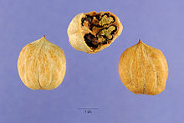  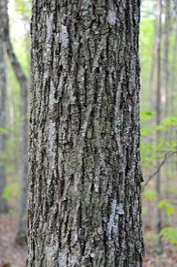  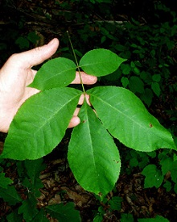 | Leaf Arrangement: Alternate  Leaf Type: Broad and Flat  Leaf Structure: Odd pinnate compound  Insects/Diseases: common disease of pignut hickory from Pennsylvania southward is a trunk rot caused by Poria spiculosa. More than 100 insects have been reported to infest hickory trees and wood products, but only a few cause death.  *Fun Fact: Pignut hickory frequently grows on dry ridgetops and side slopes throughout its range but it is also common on moist sites, particularly in the mountains and Piedmont.
Leaf Arrangement:
Leaf Type:
Leaf Structure:
Insects/Diseases:
*Fun Fact:
Leaf Arrangement:
Leaf Type:
Leaf Structure:
Insects/Diseases:
*Fun Fact:

1. Pinus strobus – Eastern White Pine
2 Acer saccharum – Sugar Maple
3. Acer rubrum - Red Maple
4. Fagus grandifolia - American Beech
5. Prunus serotine - Black Cherry
6. Carya ovata -Shagbark Hickory
7. Tsuga canadensis- Eastern Hemlock (Pa State Tree)
8. Cornus florida - Flowering Dogwood
9. Fraxinus americana - White Ash
10. Liriodendron - Tulip Tree
11. Quercus rubra - Red Oak
12. Quercus alba - White Oak
13. Juglans nigra - Black Walnut
14. Rhus glabra - Smooth Sumac
15. Robinia pseudoacacia - Black Locust

